Post-Soviet States
The post-Soviet states, also collectively known as the former Soviet Republics, are the 15 independent states that emerged from the Union of Soviet Socialist Republics in its dissolution in December 1991. With Russia internationally recognised as the successor state to the Soviet Union.

On March 11, 1990, Lithuania was the first to declare its independence, with Estonia and Latvia following suit in August 1991. All three Baltic states claimed continuity from the original states that existed prior to their annexation by the Soviet Union in 1944 and were admitted to the United Nations on 17 September 1991.

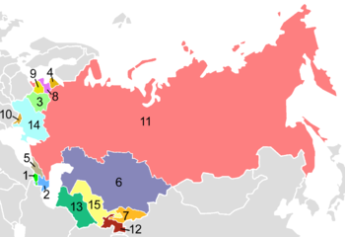
The remaining 12 republics all subsequently seceded. Twelve of the fifteen states, excluding the Baltic states, initially formed the CIS and most joined CSTO, while the Baltic states focused on European Union and NATO membership.
Post-Soviet states
- Armenia
- Azerbaijan
- Belarus
- Estonia
- Georgia
- Kazakhstan
- Kyrgyzstan
- Latvia
- Lithuania
- Moldova
- Russia
- Tajikistan
- Turkmenistan
- Ukraine
- Uzbekistan
The dissolution of the Soviet Union took place as a result and against the backdrop of general economic stagnation, even regression.

As production chains to cross the republics broke down, the inter-republic economic connections were also disrupted, leading to even more serious breakdown of the post-Soviet economies.

Most of the formerly Soviet states began the transition to a market economy in 1990-1991 and made efforts to rebuild and restructure their economic systems, with varying results.
The process triggered a severe transition decline, with Gross Domestic Product (GDP) dropping by more than 40% between 1990 and 1995. This decline in GDP was much more intense than the 27% decline that the United States suffered in the wake of the Great Depression between 1930 and 1934. The economic shock and reconfiguration to adapt to a market economy resulted in dramatically reduced public leading to a sharp increase in poverty and the deaths of roughly 1 million working age individuals throughout the former Soviet bloc in the 1990s.

The transition decline was eventually arrested by the cumulative effect of market reforms, and after 1995 the economy in the post-Soviet states began to recover.
This could be perceived as failure of capitalism to improve the standard of living in Russia, and combined with the aftershocks of the 1998 economic crisis it led to a return of more interventionist economic policies by Vladimir Putin's administration.^{[citation needed]}

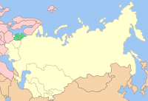
CIS members
States that joined EU and NATO
Other EU or NATO members

A number of regional organisations and cooperating blocs have sprung up since the dissolution of the Soviet Union. The 15 post-Soviet states are divided in their participation to the regional blocs:
- Belarus, Russia, and Ukraine founded the Commonwealth of Independent States (CIS) in December 1991 - conceived as a successor organisation to the USSR, and as of December 1993 it included 12 of the 15 former Soviet republics (except the three Baltic states).
- The three Baltic states have not sought membership to any of these post-Soviet organisations, seeking and achieving membership in the European Union and NATO instead (only their electricity and rail systems remain closely connected with former Soviet organisations).
- The Eurasian Economic Community (later merged with Eurasian Economic Union, Collective Security Treaty Organization, and the Shanghai Cooperation Organization.
In 1994, the CIS countries agreed to create a free trade area, but the agreements were never signed. Seven CIS member states, namely Russia, Belarus, Kazakhstan, Kyrgyzstan, Tajikistan, Uzbekistan and Armenia, have enhanced their military cooperation, establishing the Collective Security Treaty Organization (CSTO),

North Atlantic Treaty Organization
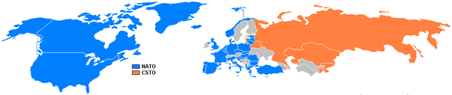
NATO/CSTO
Three former Soviet states became members of NATO during the early 2000’s: Estonia, Latvia and Lithuania. Georgia. The European Union welcomed ten new Member States on 1 May, 2004, including three former Soviet republics (Estonia, Latvia and Lithuania), four former satellites of the USSR (the Czech Republic, Hungary, Poland and Slovakia), a former Yugoslav republic (Slovenia)

GUAM: Organization for Democracy and Economic Development
Four member states, namely Georgia, Ukraine, Azerbaijan and Moldova began to establish the GUAM group during the late 1990s, largely seen as intending to counter Russian dominance in the region.

Politics
Regarding political freedom in the former Soviet republics, Freedom House's 2015 report listed the following:
It has been remarked that several post-Soviet states have not changed leadership since their independence
Economic, political, national, military, and social problems have all been factors in separatism in the Post-Soviet space. In many cases, problems due to factors such as ethnic divisions existed

Religion
While the Soviet system placed severe restrictions on religious intellectual life, traditions continued to survive. After the dissolution of the Soviet Union, Islamic movements have emerged alongside ethnic and secular ones.
In most countries, religiosity has increased since the Soviet collapse.

Post-Soviet nostalgia
Ever since the dissolution of the Soviet Union a certain number of people have expressed a longing for the Soviet period and its values. The level of post-Soviet nostalgia varies across the former republics.

